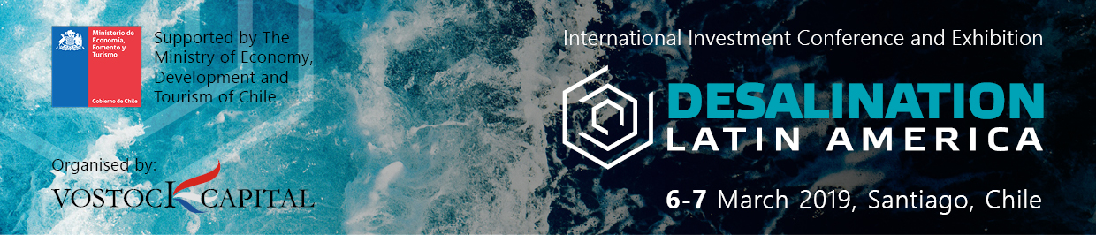
35+ major investment projects for desalination plant construction
will be presented at the International Investment Conference and Exhibition Desalination Latin America

Date: 6-7 March 2019
Venue: Santiago, Chile, NH Collection Plaza Santiago.
Organiser: Vostock Capital
Website: https://desalinationlatinamerica.com/
The International Investment Conference and Exhibition “DESALINATION LATIN AMERICA” is the sole business venue for developing effective strategies, sharing experiences, presenting new investment projects and innovations, and consolidating government and business efforts to implement desalination projects and increase water supplies all over Latin America.
Facts and Figures for Desalination Latin America 2019:
- 200+ decision-makers of desalination industry from all over Latin America – Chile, Peru, Mexico, Colombia, Panama, etc, as well as government officials, regulatory bodies, project owners, technology and service providers, international and local investors
- Important! Permits - how to accelerate the process? Ask your burning questions to governments of Chile, Peru, Mexico and their regulatory bodies!
- Presentation of 20+ large-scale investment desalination projects to be implemented within 2020-2025 from all Latin America
- COUNTRY ROUND TABLES on desalination projects in Chile, Peru and Mexico – learn about governments plans, their desalination projects and ways to successfully do business in these countries!
- Among VIP guests: Jorge Geldres (Bacigalupo Ministerio de Economía, Fomento y Turismo de Chile - Oficina Gestión de Proyectos Sustentables- Minister’s Adviser), Oscar Cristi (Ministerio de Obras Publicas Chile - General Water Director), Ricardo Cisneros (Comición Estatal de Agua de Baja California México -President), Pedro Ducci (Andes Iron – CFO),Rodrigo Silva (ENAPAC Trends Industrial – CEO), José N. De Pierola Canales (Southern Peru Copper Corp - Water Resources Director), Jose Antonio Ramirez (CKC Chile – Director), Vasilis Fthenakis (Columbia University - Director, Center for Life Cycle Analysis), Tom Pankratz (Global Water Intelligence - Editor and consultant), Humberto Catacora (Unión de la Cervecerías Peruanas Backus & Johnston - Regional Quality Manager)
- Exclusive exhibition and showcase of technologies, delivered by innovative technological companies Including Suez, Dow Chemical Company, GS Inima, Fitchner, Cobra, Poyry, Tedagua, ABB, Rotork, LG, and more
- Unprecedented networking opportunities! 1-2-1 business meetings, networking round tables, cocktail reception, interactive discussions. Use this opportunity to exchange business cards with ALL conference participants!

Among VIP Guests and Speakers:
- Jorge Geldres Bacigalupo, Minister’s Adviser, Oficina Gestión de Proyectos Sustentables (GPS), Ministerio de Economía, Fomento y Turismo de Chile.
- Oscar Cristi, General Water Director, Ministerio de Obras Publicas Chile.
- Ricardo Cisneros, President, Comición Estatal de Agua de Baja California, México
- Pedro Ducci, CFO, Andes Iron
- Rodrigo Silva, CEO, ENAPAC (Trends Industrial)
- José N. De Pierola Canales, Water Resources Director, Southern Peru Copper Corp.
- Jose Antonio Ramirez, Director, CKC Chile
- Vasilis Fthenakis, Director, Center for Life Cycle Analysis, Columbia University
- Tom Pankratz, Editor and consultant, Global Water Intelligence
- Humberto Catacora, Regional Quality Manager, Unión de la Cervecerías Peruanas Backus & Johnston.
Contact: Ana Uzcanga, Conference Producer
Tel.: +44 207 394 30 90 (London)
E-mail: AUzcanga@vostockcapital.com
Website: https://desalinationlatinamerica.com/

